Browser Object Model

The **Browser Object Model** (BOM) is used to interact with the browser.

The default object of browser is window means you can call all the functions of window by specifying window or directly. For example:

window.alert("hello friend");

is same as:

alert("hello friend");

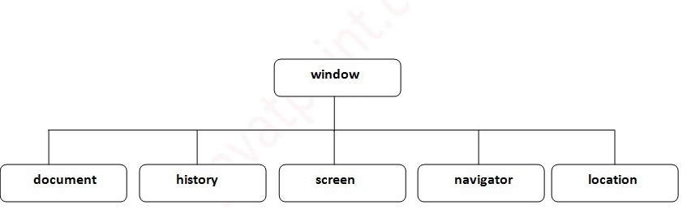

Window Object

The **window object** represents a window in browser. An object of window is created automatically by the browser.

Window is the object of browser, **it is not the object of javascript**. The javascript objects are string, array, date etc.

## **Methods of window object**

The important methods of window object are as follows:

|  |  |
| --- | --- |
| **Method** | **Description** |
| alert() | displays the alert box containing message with ok button. |
| confirm() | displays the confirm dialog box containing message with ok and cancel button. |
| prompt() | displays a dialog box to get input from the user. |
| open() | opens the new window. |
| close() | closes the current window. |
| setTimeout() | performs action after specified time like calling function, evaluating expressions etc. |
| setInterval() | To call a function again again at a within a given time. |
| print() | To print web page |

## window.open(<http://www.google.com>);

window.close();

Example otsetTimeout function.

<head>

<script>

functiondisp()

{

window.location="http://www.google.com";

}

</script>

</head>

<body>

<script>

setTimeout("disp()",2000);

</script>

<h1>HellloDps</h1>

</body>

Example of print()

<head>

</head>

<body>

<h1>Head1</h1>

<h1 id="m">Two</h1>

<h1>Three</h1>

<input type="button" value="PrintNow" onclick="window.print()">

</body>

**JavaScript History Object**

The **JavaScript history object** represents an array of URLs visited by the user. By using this object, you can load previous, forward or any particular page.

The history object is the window property, so it can be accessed by:

window.history

Or,

history

## **Property of JavaScript history object**

There are only 1 property of history object.

|  |  |  |
| --- | --- | --- |
| **No.** | **Property** | **Description** |
| 1 | Length | returns the length of the history URLs. |

## **Methods of JavaScript history object**

There are only 3 methods of history object.

|  |  |  |
| --- | --- | --- |
| **No.** | **Method** | **Description** |
| 1 | forward() | loads the next page. |
| 2 | back() | loads the previous page. |
| 3 | go() | loads the given page number. |

history.back();

history.forward();

history.go(2);

JavaScript Navigator Object

The **JavaScript navigator object** is used for browser detection. It can be used to get browser information such as appName, appCodeName, userAgent etc.

The navigator object is the window property, so it can be accessed by:

window.navigator

or

navigator

**<script>**

document.writeln("**<br/>**navigator.appCodeName: "+navigator.appCodeName);

document.writeln("**<br/>**navigator.appName: "+navigator.appName);

document.writeln("**<br/>**navigator.appVersion: "+navigator.appVersion);

document.writeln("**<br/>**navigator.cookieEnabled: "+navigator.cookieEnabled);

document.writeln("**<br/>**navigator.language: "+navigator.language);

document.writeln("**<br/>**navigator.userAgent: "+navigator.userAgent);

document.writeln("**<br/>**navigator.platform: "+navigator.platform);

document.writeln("**<br/>**navigator.onLine: "+navigator.onLine);

**</script>**

## **Property of JavaScript Screen Object**

There are many properties of screen object that returns information of the browser.

|  |  |  |
| --- | --- | --- |
| **No.** | **Property** | **Description** |
| 1 | Width | returns the width of the screen |
| 2 | Height | returns the height of the screen |
| 3 | availWidth | returns the available width |
| 4 | availHeight | returns the available height |

Document Object

The **document object** represents the whole html document.

window.document

Is same as

document

## **Methods of document object**

We can access and change the contents of document by its methods.

The important methods of document object are as follows:

|  |  |
| --- | --- |
| **Method** | **Description** |
| write("string") | writes the given string on the doucment. |
| writeln("string") | writes the given string on the doucment with newline character at the end. |
| getElementById() | returns the element having the given id value. |
| getElementsByName() | returns all the elements having the given name value. |
| getElementsByTagName() | returns all the elements having the given tag name. |

Example 1:

<head>

<script>

functiondisp()

{

document.getElementById("m").innerHTML="KBC";

}

</script>

</head>

<body>

<h1>Head1</h1>

<h1 id="m">Two</h1>

<h1>Three</h1>

<input type="button" value="change" onclick="disp()">

</body>

<head>

<script>

functiondisp()

{

document.getElementsByTagName("h1")[1].innerHTML="KBCVBVB";

}

</script>

</head>

<body>

<h1>Head1</h1>

<h1>Two</h1>

<h1>Three</h1>

<input type="button" value="change" onclick="disp()">

</body>

Exapmle 3

1. **<script** type="text/javascript"**>**
2. function totalelements()
3. {
4. var a=document.getElementsByName("gender");
5. alert("Total Genders:"+a.length);
6. }
7. **</script>**
8. **<form>**
9. Male:**<input** type="radio" name="gender" value="male"**>**
10. Female:**<input** type="radio" name="gender" value="female"**>**
12. **<input** type="button" onclick="totalelements()" value="Total Genders"**>**
13. **</form>**

# Javascript - innerHTML

The **innerHTML** property can be used to write the dynamic html on the html document.

Where html tag consider as a tag

k.innerHTML=”<b>msg</b>”; // message displayed in bold style

# Javascript–innerText::

To change content of any tag where HTML tag consider as a text.

k.innerText=”<b>msg</b>”; //

o./p

<b>msg</b>

location:-

==========

It is used to change the URL.

Window.location=<http://www.google.com>;